Brainstorming – Idea Generation & Prioritization

Date | 04-11-2025
Team id | NM2025TMID02289
Project Title | Educational Organization Using Service Now
Maximum Marks | 4 marks

In modern educational institutions, managing academic and administrative operations efficiently has become a critical challenge. ServiceNow, an advanced cloud-based workflow automation platform, offers the potential to streamline these complex processes while integrating Artificial Intelligence (AI) to enhance decision-making. This project, “Educational Organization Using ServiceNow”, aims to design a digital ecosystem that connects students, faculty, and administrators seamlessly. The objective is to automate student registration, course management, grievance handling, and notification delivery through an intelligent portal built within ServiceNow. The envisioned solution creates a smart campus environment where all stakeholders collaborate through structured and automated workflows—reducing manual effort, improving transparency, and fostering innovation.

Setting the Stage: The Need for Structured Brainstorming
Educational environments are naturally fertile for innovation—new ideas emerge daily regarding how to improve learning engagement, academic administration, research collaboration, and student experience. However, without a structured mechanism to capture and prioritize ideas, many valuable suggestions are lost or ignored. Traditional brainstorming techniques often focus only on idea generation, neglecting the critical stages of categorization, evaluation, and implementation. ServiceNow addresses these gaps by introducing a robust, AI-enabled framework for capturing, refining, and prioritizing innovative ideas in an educational context.

ServiceNow for Idea Capture and Brainstorming
ServiceNow provides several modules and customizable tools to support structured ideation: Idea Portal (Innovation Management): A centralized platform where users submit and track ideas, tagged with keywords and linked to departments or initiatives. AI-driven analysis can suggest idea clustering and duplication detection. Knowledge Base Integration: New ideas automatically connect to existing knowledge articles,
promoting reuse of solutions and preventing redundant efforts. Service Catalog for Idea Submission: A structured submission form ensures consistency by capturing problem statements, proposed solutions, impacts, and required resources. Collaboration Tools:
Real-time chat and virtual agents support brainstorming sessions, enabling
cross-functional input and continuous refinement of ideas. Custom Applications: ServiceNow supports custom low-code apps for visual brainstorming, digital whiteboards, and design thinking canvases, making the ideation process more interactive and traceable.

Idea Evaluation and Prioritization Criteria
To move from raw ideas to actionable initiatives, ServiceNow’s AI and analytics features

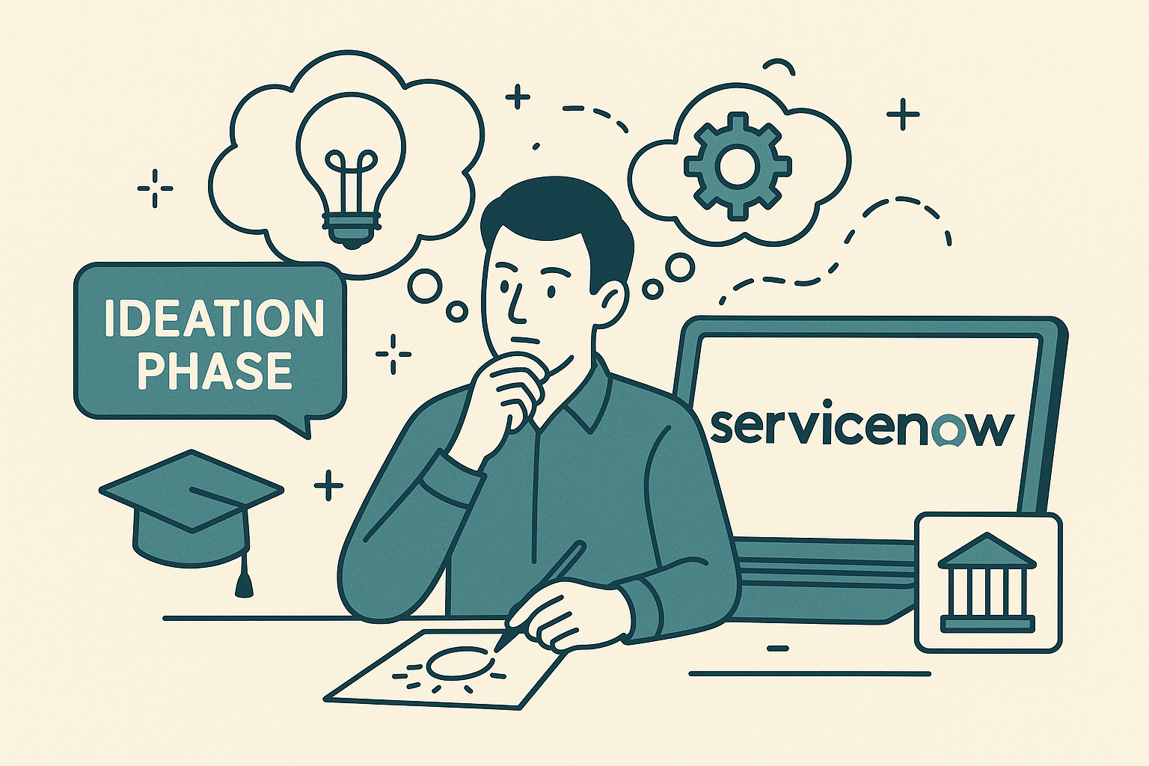
can assist in evaluating each idea using measurable criteria such as: Feasibility – Can the idea be realistically implemented within existing constraints? Impact – What measurable benefit will the idea provide to students, faculty, or administration? Innovation Level – Does the idea introduce a novel approach or technology? Alignment – How well does it align with institutional goals and ServiceNow’s capabilities? Resource Efficiency – What level of time, cost, and personnel will be required? The prioritization matrix within ServiceNow allows stakeholders to visually compare and rank ideas, ensuring that the most valuable and achievable concepts are implemented first.

AI-Enhanced Innovation and Implementation
The integration of AI into ServiceNow enhances innovation management by offering predictive analytics, automated feedback loops, and recommendation systems. Natural Language Processing (NLP) enables automatic idea tagging and categorization, while machine learning models can forecast the potential success of proposed initiatives. This transformation creates a culture of continuous improvement and evidence-based decision-making in academic administration.

Conclusion
The structured approach to brainstorming and idea prioritization provided by ServiceNow and AI tools allows educational organizations to manage innovation effectively. By creating a transparent, data-driven system, institutions can capture creativity, convert it into practical strategies, and drive long-term organizational growth. This methodology transforms brainstorming from a spontaneous act into a systematic process for institutional advancement.

